This assignment is to use .NET Core, MVC and EntityFramework Code First to create database tables, populate the tables with a small sample of test data, and create a WebAPI to read the data from the database to return to the browser. Use Chrome or another browser to type in your URL and see the data returned.

Figure 1: Logical Data Model
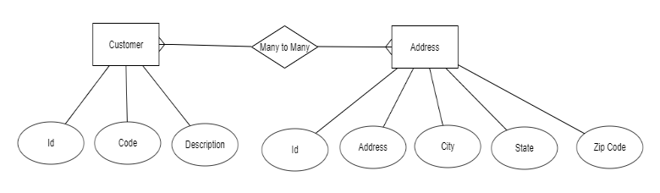
- Create the Database entities using EntityFramework Core Code First. Please notice that the above is a logical model and there is a many to many relationship between Customer and Address. Make sure you properly implement the many to many relationship in the physical model.
- Use EF Migrations to create the tables in a SQL Server or SQLite database.
- Create an MVC Controller CustomerController that has a Get endpoint to return a JSON string of customers, with all of their associated addresses. The CustomerDTO should contain a list of AddressDTOs.
- Create a CustomerService that is injected in the CustomerController using the DependencyInjector that is part of .NET Core.
- The CustomerService should have a method that reads the customers and addresses from the database using EF Core.
- The DbContext should be injected into the CustomerService.

